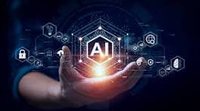

ARTIFICIAL INTELLIGENCE

ARTIFICIAL INTELLIGENCE AI is a ability of a computer to think learn and make decisions like human it uses data and algorithm, to solve problems recognize patterns and perform tasks.

